**EXERCISE 1:**

**ListofPlayers.jsx**

import React from "react";

const ListofPlayers = () => {

  const players = [

    { name: "Virat", score: 85 },

    { name: "Rohit", score: 45 },

    { name: "Rahul", score: 75 },

    { name: "Gill", score: 66 },

    { name: "Iyer", score: 59 },

    { name: "Pant", score: 90 },

    { name: "Jadeja", score: 30 },

    { name: "Ashwin", score: 70 },

    { name: "Bumrah", score: 80 },

    { name: "Shami", score: 50 },

    { name: "Siraj", score: 40 },

  ];

  // Task: map to display players

  const playerList = players.map((p, index) => (

    <li key={index}>

      {p.name} - Score: {p.score}

    </li>

  ));

  // Task: filter score < 70 using arrow function

  const below70 = players.filter(p => p.score < 70);

  return (

    <div>

      <h2>All Players</h2>

      <ul>{playerList}</ul>

      <h3>Players with score below 70</h3>

      <ul>

        {below70.map((p, index) => (

          <li key={index}>{p.name} - {p.score}</li>

        ))}

      </ul>

    </div>

  );

};

export default ListofPlayers;

**IndianPlayers.jsx**

import React from "react";

const IndianPlayers = () => {

  const players = ["Virat", "Rohit", "Rahul", "Gill", "Iyer", "Pant"];

  // Destructuring: odd/even team players

  const oddTeam = players.filter((_, i) => i % 2 === 0);

  const evenTeam = players.filter((_, i) => i % 2 !== 0);

  const T20players = ["Samson", "Suryakumar", "Bishnoi"];

  const RanjiPlayers = ["Pujara", "Rahane", "Saha"];

  // Merging arrays

  const allPlayers = [...T20players, ...RanjiPlayers];

  return (

    <div>

      <h2>Odd Team Players</h2>

      <ul>

        {oddTeam.map((p, index) => <li key={index}>{p}</li>)}

      </ul>

      <h2>Even Team Players</h2>

      <ul>

        {evenTeam.map((p, index) => <li key={index}>{p}</li>)}

      </ul>

      <h2>Merged T20 + Ranji Players</h2>

      <ul>

        {allPlayers.map((p, index) => <li key={index}>{p}</li>)}

      </ul>

    </div>

  );

};

export default IndianPlayers;

**OUTPUT:**

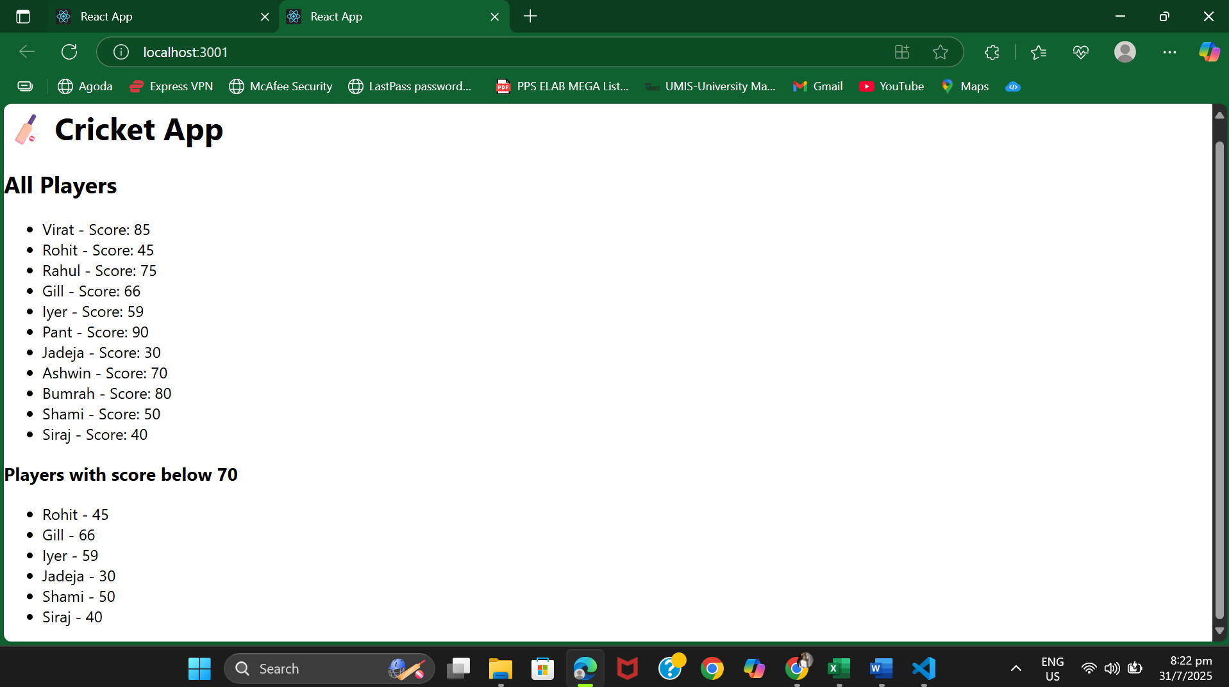

**EXERCISE 2:**

**App.js**

import React from "react";

import officeImage from "./Office.jpg"; // put an office image in src folder

import "./App.css";

function App() {

  // Office object

  const office = {

    name: "MKC Office Space",

    rent: 45000,

    address: "100 Feet Road, Chennai",

  };

  // List of office spaces

  const officeList = [

    {

      name: "Green Tech Park",

      rent: 55000,

      address: "Anna Nagar, Chennai",

    },

    {

      name: "IT Bay Space",

      rent: 75000,

      address: "OMR, Chennai",

    },

    {

      name: "Startup Hub",

      rent: 35000,

      address: "Tidel Park, Coimbatore",

    },

  ];

  return (

    <div className="App">

      {/* JSX Heading */}

      <h1>🏢 Office Space Rental Portal</h1>

      {/* JSX Image with attribute */}

      <img src={officeImage} alt="Office Space" width="400" />

      {/* JSX from Object */}

      <div style={{ border: "1px solid gray", margin: "10px", padding: "10px" }}>

        <h2>{office.name}</h2>

        <p>Address: {office.address}</p>

        <p style={{ color: office.rent < 60000 ? "red" : "green" }}>

          Rent: ₹{office.rent}

        </p>

      </div>

      {/* List of Objects with JSX & Conditional CSS */}

      <h2>🏙️ More Available Spaces:</h2>

      {officeList.map((item, index) => (

        <div

          key={index}

          style={{

            border: "1px solid gray",

            margin: "10px",

            padding: "10px",

            backgroundColor: "#f9f9f9",

          }}

        >

          <h3>{item.name}</h3>

          <p>Address: {item.address}</p>

          <p style={{ color: item.rent < 60000 ? "red" : "green" }}>

            Rent: ₹{item.rent}

          </p>

        </div>

      ))}

    </div>

  );

}

export default App;

**OUTPUT:**

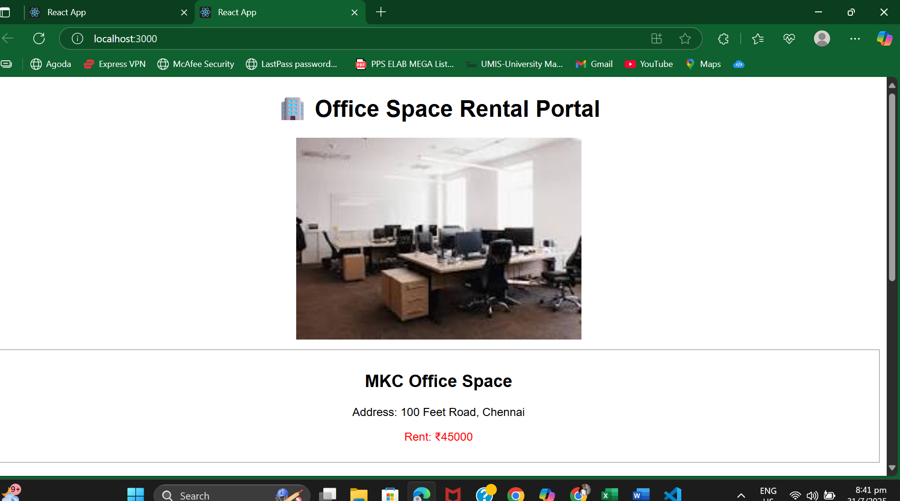

**EXERCISE 3:**

**App.jsx**

import React, { useState } from "react";

import "./App.css";

function App() {

  const [count, setCount] = useState(0);

  const [rupees, setRupees] = useState("");

  const [euro, setEuro] = useState("");

  // Multiple methods for Increment button

  const handleIncrement = () => {

    sayHello();

    setCount(prev => prev + 1);

  };

  const sayHello = () => {

    alert("Hello! Counter incremented.");

  };

  const handleDecrement = () => {

    setCount(prev => prev - 1);

  };

  // Button with argument

  const sayWelcome = (message) => {

    alert(`Welcome! Message: ${message}`);

  };

  // Synthetic event handler

  const handlePress = (e) => {

    e.preventDefault(); // Synthetic event

    alert("I was clicked");

  };

  // Currency Convertor logic

  const handleCurrencySubmit = (e) => {

    e.preventDefault();

    const euroValue = parseFloat(rupees) / 90; // Approx conversion

    setEuro(euroValue.toFixed(2));

  };

  return (

    <div className="App">

      <h1>🌟 Event Examples App</h1>

      {/* Increment & Decrement Buttons */}

      <h2>Counter: {count}</h2>

      <button onClick={handleIncrement}>Increment</button>

      <button onClick={handleDecrement}>Decrement</button>

      {/* Button with argument */}

      <br /><br />

      <button onClick={() => sayWelcome("Happy to see you!")}>Say Welcome</button>

      {/* Synthetic Event Example */}

      <br /><br />

      <button onClick={handlePress}>Synthetic OnPress</button>

      {/* Currency Convertor */}

      <br /><br />

      <h2>Currency Convertor: ₹ → €</h2>

      <form onSubmit={handleCurrencySubmit}>

        <input

          type="number"

          value={rupees}

          onChange={(e) => setRupees(e.target.value)}

          placeholder="Enter Rupees"

        />

        <button type="submit">Convert</button>

      </form>

      {euro && <p>💶 Euro: €{euro}</p>}

    </div>

  );

}

export default App;

**OUTPUT:**

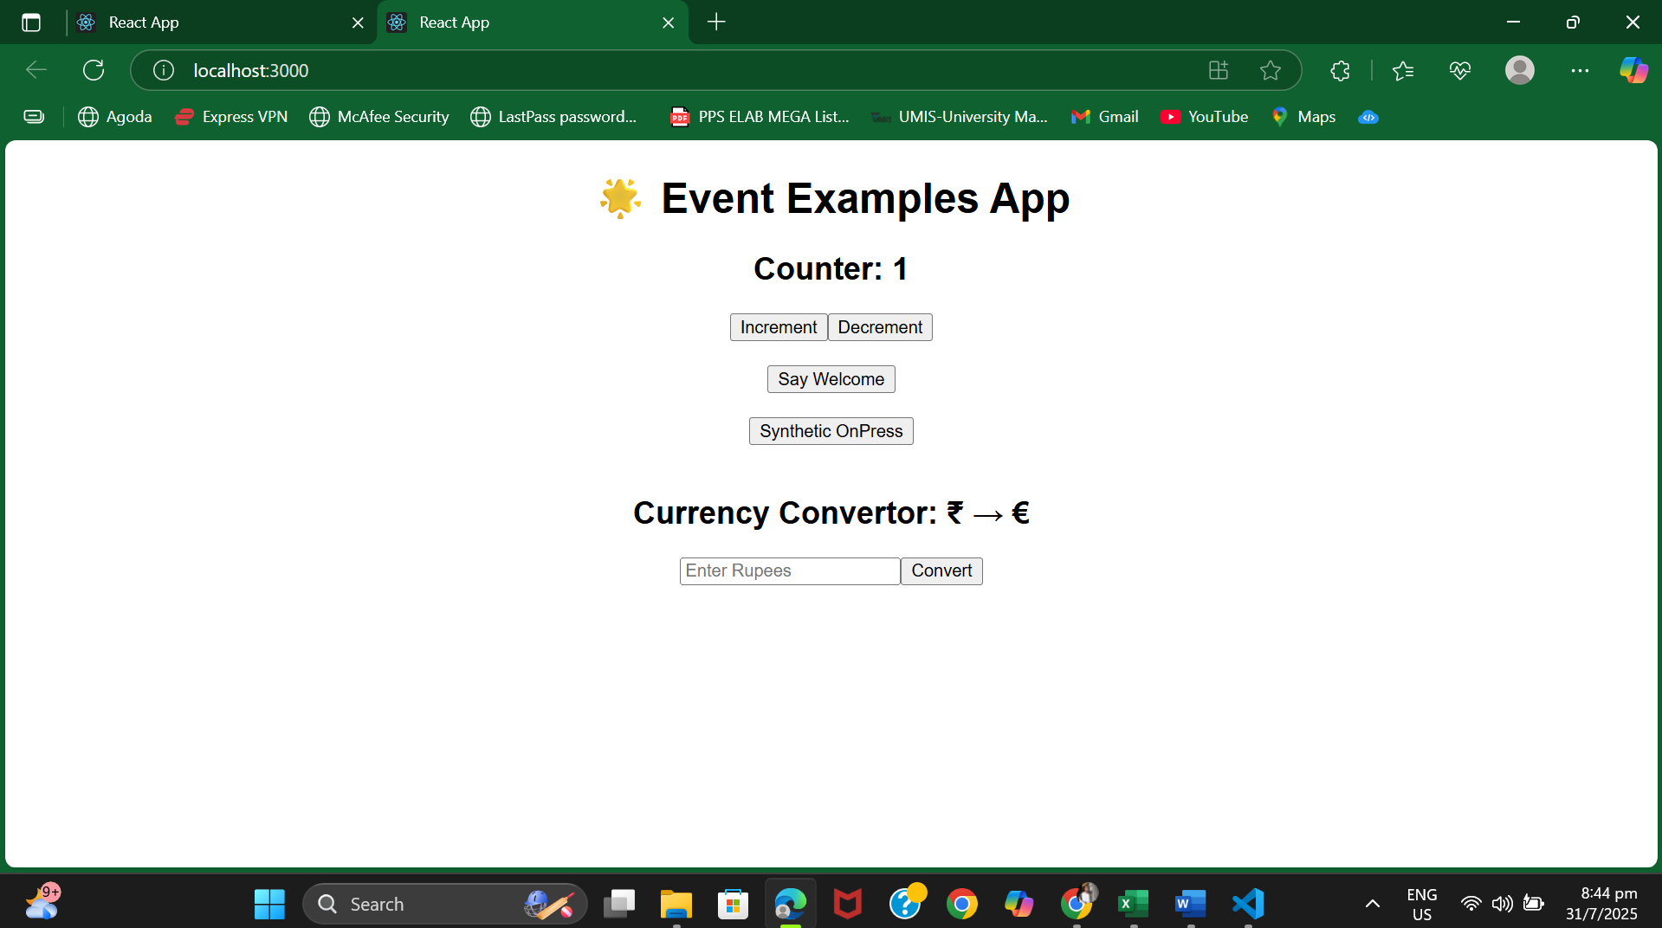

**EXERCISE 4:**

**App.jsx**

import React, { useState } from "react";

import GuestPage from "./GuestPage";

import UserPage from "./UserPage";

import "./App.css";

function App() {

  const [isLoggedIn, setIsLoggedIn] = useState(false);

  // Toggle Login State

  const handleLogin = () => {

    setIsLoggedIn(true);

  };

  const handleLogout = () => {

    setIsLoggedIn(false);

  };

  // Use element variable for conditional rendering

  let content;

  if (isLoggedIn) {

    content = <UserPage />;

  } else {

    content = <GuestPage />;

  }

  return (

    <div className="App">

      <h1>🎫 Ticket Booking App</h1>

      {/* Login/Logout button based on condition */}

      {isLoggedIn ? (

        <button onClick={handleLogout}>Logout</button>

      ) : (

        <button onClick={handleLogin}>Login</button>

      )}

      <hr />

      {/* Conditional Page Content */}

      {content}

    </div>

  );

}

export default App;

**GuestPage.jsx**

import React from "react";

const GuestPage = () => {

return (

<div>

<h2>Welcome, Guest ✈️</h2>

<p>Browse available flights and details.</p>

<ul>

<li>Chennai ➜ Bangalore – ₹2500</li>

<li>Mumbai ➜ Delhi – ₹3500</li>

<li>Kolkata ➜ Hyderabad – ₹3000</li>

</ul>

</div>

);

};

export default GuestPage;

**UserPage.jsx**

import React from "react";

const UserPage = () => {

return (

<div>

<h2>Welcome, User 👤</h2>

<p>You can now book tickets:</p>

<ul>

<li>✅ Chennai ➜ Bangalore</li>

<li>✅ Mumbai ➜ Delhi</li>

<li>✅ Kolkata ➜ Hyderabad</li>

</ul>

<button>Proceed to Book</button>

</div>

);

};

export default UserPage;

**OUTPUT:**

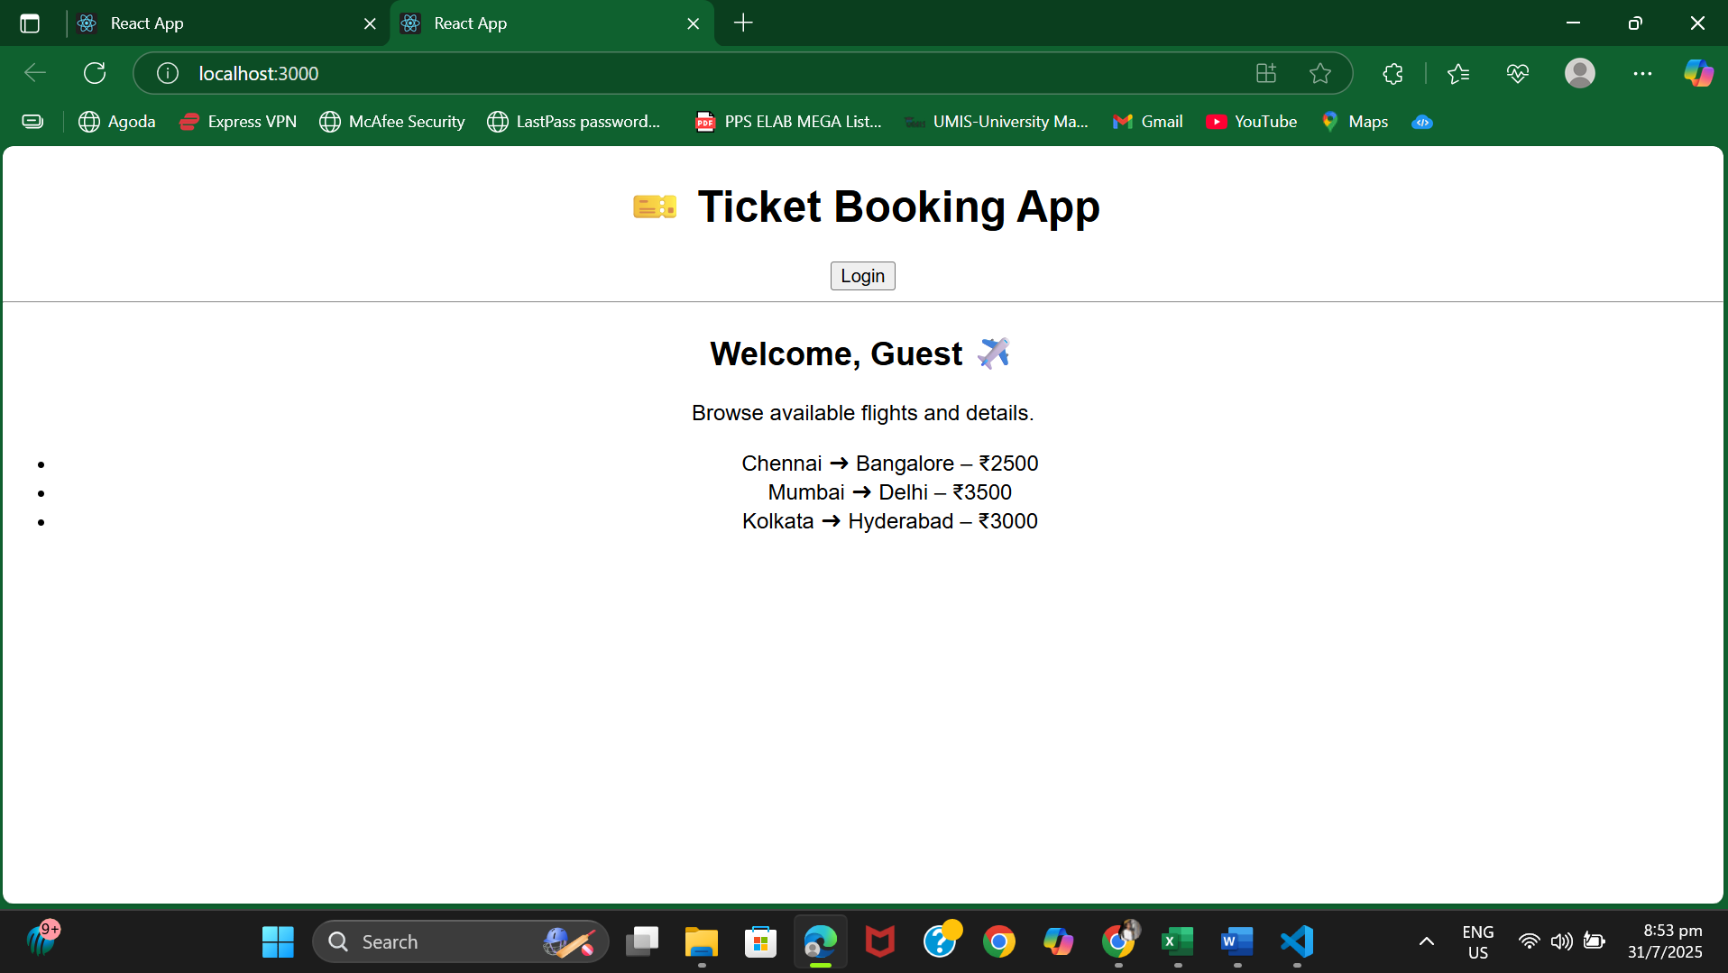

**EXERCISE 5:**

**App.jsx**

import React, { useState } from "react";

import BookDetails from "./BookDetails";

import BlogDetails from "./BlogDetails";

import CourseDetails from "./CourseDetails";

import "./App.css";

function App() {

  const [selected, setSelected] = useState("book");

  // Option 1: if-else

  let content;

  if (selected === "book") {

    content = <BookDetails />;

  } else if (selected === "blog") {

    content = <BlogDetails />;

  } else {

    content = <CourseDetails />;

  }

  return (

    <div className="App">

      <h1>📰 BloggerApp</h1>

      {/* Option 2: Ternary Operator */}

      <div>

        <button onClick={() => setSelected("book")}>Book</button>

        <button onClick={() => setSelected("blog")}>Blog</button>

        <button onClick={() => setSelected("course")}>Course</button>

      </div>

      <hr />

      {/* Option 3: Switch style via element variable */}

      {content}

    </div>

  );

}

export default App;

**BookDetails.jsx**

import React from "react";

const BookDetails = () => {

const books = [

{ id: 1, title: "React Basics", author: "John Doe" },

{ id: 2, title: "Mastering JS", author: "Jane Smith" },

];

return (

<div>

<h2>📚 Book Details</h2>

<ul>

{books.map(book => (

<li key={book.id}>

{book.title} by {book.author}

</li>

))}

</ul>

</div>

);

};

export default BookDetails;

**BlogDetails.jsx**

import React from "react";

const BlogDetails = () => {

const blogs = [

{ id: 1, topic: "React Rendering", writer: "Alan" },

{ id: 2, topic: "Hooks Overview", writer: "Sara" },

];

return (

<div>

<h2>📝 Blog Details</h2>

<ul>

{blogs.map(blog => (

<li key={blog.id}>

"{blog.topic}" by {blog.writer}

</li>

))}

</ul>

</div>

);

};

export default BlogDetails;

**CourseDetails.jsx**

import React from "react";

const CourseDetails = () => {

const courses = [

{ id: 1, name: "React for Beginners", duration: "4 weeks" },

{ id: 2, name: "Advanced React", duration: "6 weeks" },

];

return (

<div>

<h2>🎓 Course Details</h2>

<ul>

{courses.map(course => (

<li key={course.id}>

{course.name} – {course.duration}

</li>

))}

</ul>

</div>

);

};

export default CourseDetails;

**OUTPUT:**

